# Exercise 1: Logging Error Messages and Warning Levels Task:

Write a Java application that demonstrates logging error messages and warning levels using SLF4J.

Adding Dependencies –

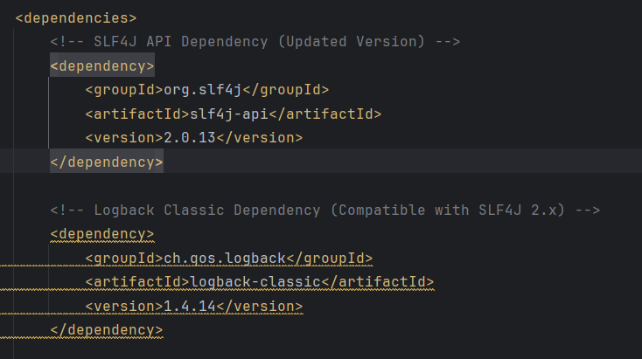

Code -

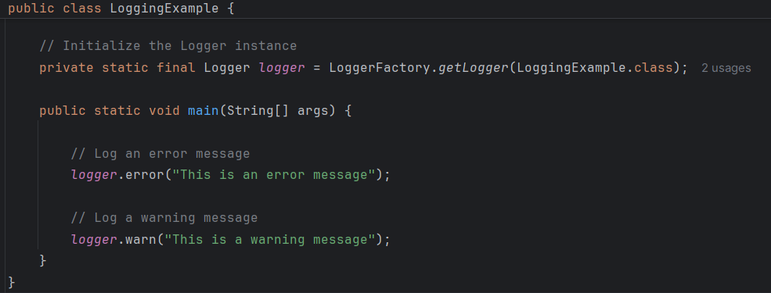

Output –

